ASSIGNMENT 3

NAME – KONAKALLA AKHILA ROLL NUMBER – DXC-262-AB-1225

BATCH – DXC-262-ANALYTICS-B12-AZURE COMPANY – DXC TECHNOLOGY EMPLOYEE DOMAIN –AZURE ANALYTICS

TRAINING UNDER – MANIPAL PRO LEARN TRAINER NAME – MR. AJAY KUMAR

DATE OF SUBMISSION – 2nd JUNE 2022 NO.OF CASES: 15

CASE 33 : From the following table, write a SQL query to find those employees of department id 3001 or 1001  
and joined in the year 1991. Return complete information about the employees

QUERY: **select *from GLOBETECHTB231 where to_char(HIRE_DATE,'YYYY')='1991' and (DEP_ID='3001' or DEP_ID='1001');**

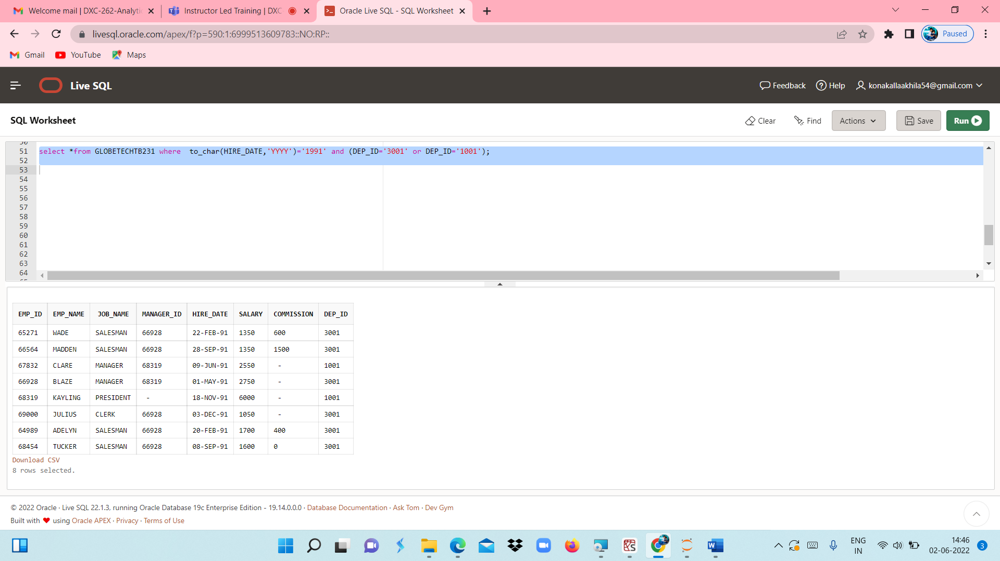

CASE 34 : From the following table, write a SQL query to find those employees who are working for the department ID 1001 or 2001.Return complete information about the employees

QUERY **: select *from GLOBETECHTB231 where (( DEP_ID =1001) or (DEP_ID=2001));**

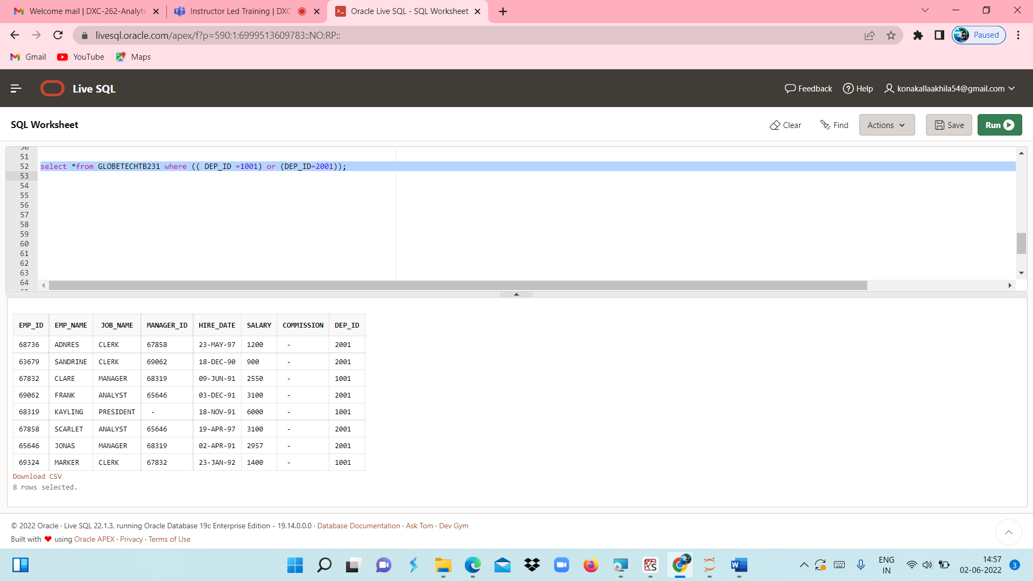

CASE 35 : From the following table, write a SQL query to find those employees whose designation is ‘CLERK’ and work in the department ID 2001.Return complete information about the employees.

QUERY**: select *from GLOBETECHTB231 where JOB_NAME='CLERK' and DEP_ID=2001;**

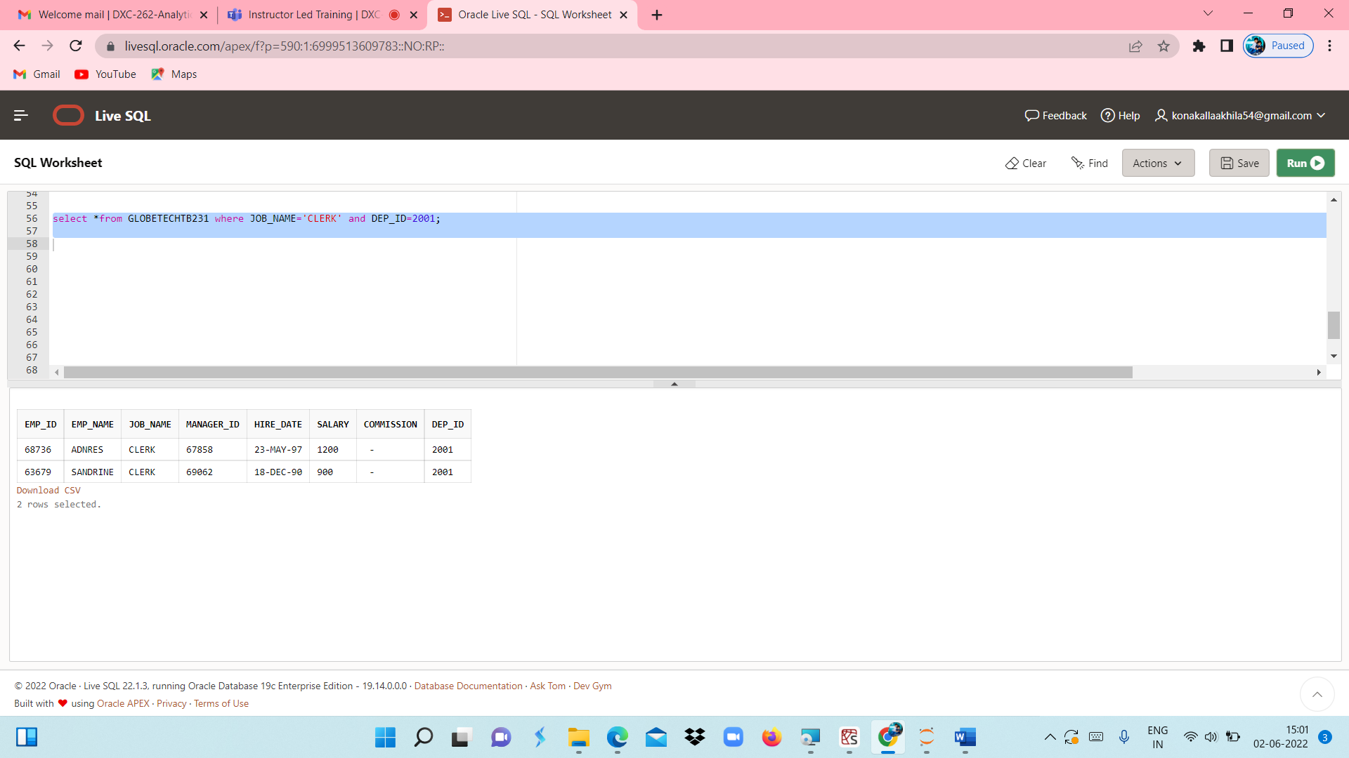

CASE 36 : From the following table, write a SQL query to find those employees who are either CLERK or MANAGER.  
Return complete information about the employees

QUERY : **select *from GLOBETECHTB231 where JOB_NAME='CLERK' or JOB_NAME='MANAGER';**

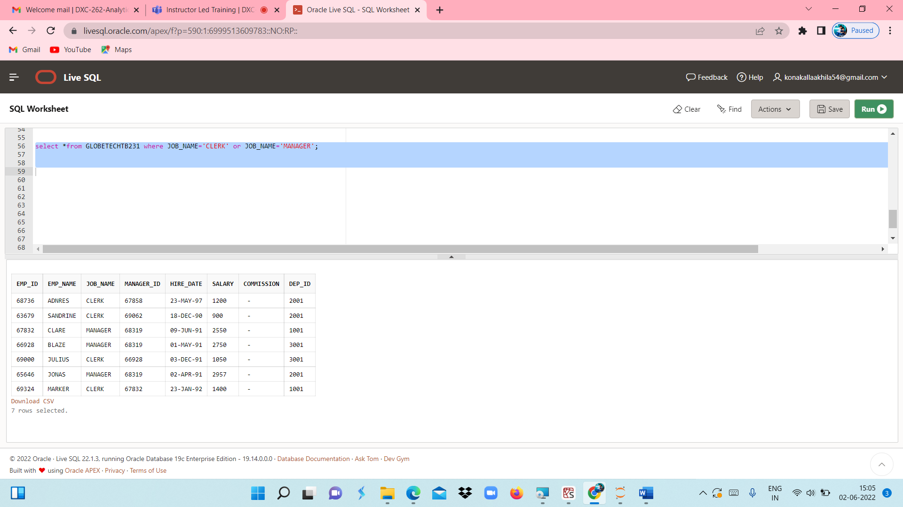

CASE 37 : From the following table, write a SQL query to find those employees who joined in any year except the month of February.Return complete information about the employees

QUERY **: select *from GLOBETECHTB231 where to_char(HIRE_DATE,'MM')='02';**

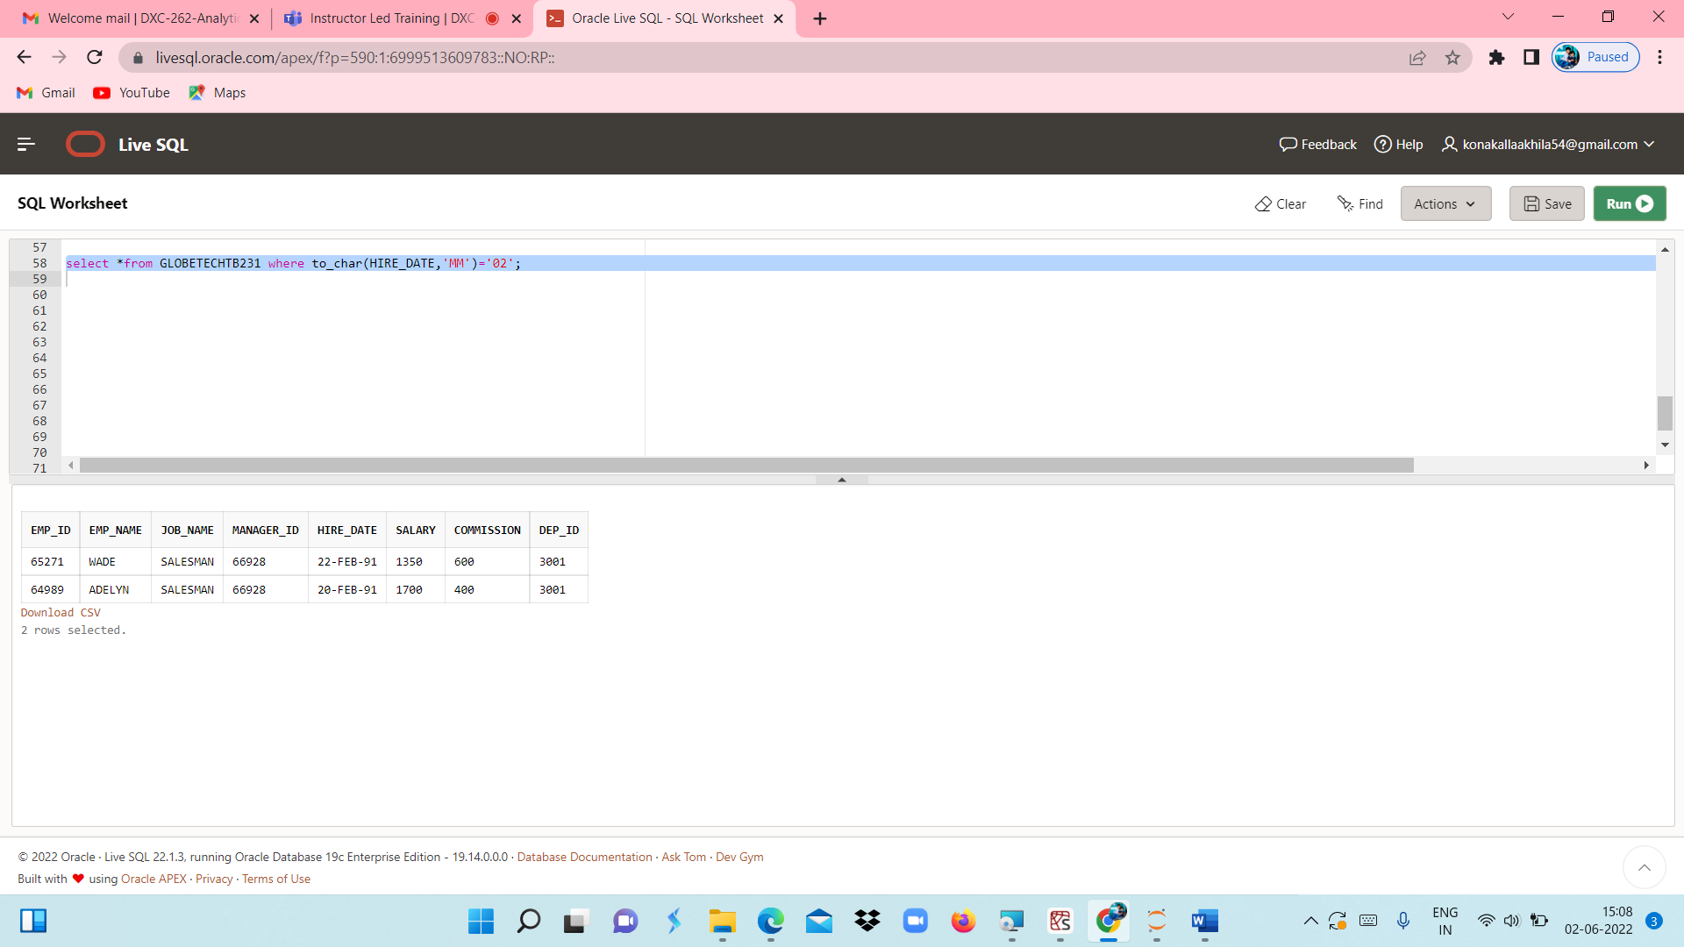

CASE 38 : From the following table, write a SQL query to find those employees who joined in the year 91.  
Return complete information about the employees

QUERY : **select *from GLOBETECHTB231 where to_char(HIRE_DATE,'YYYY')='1991';**

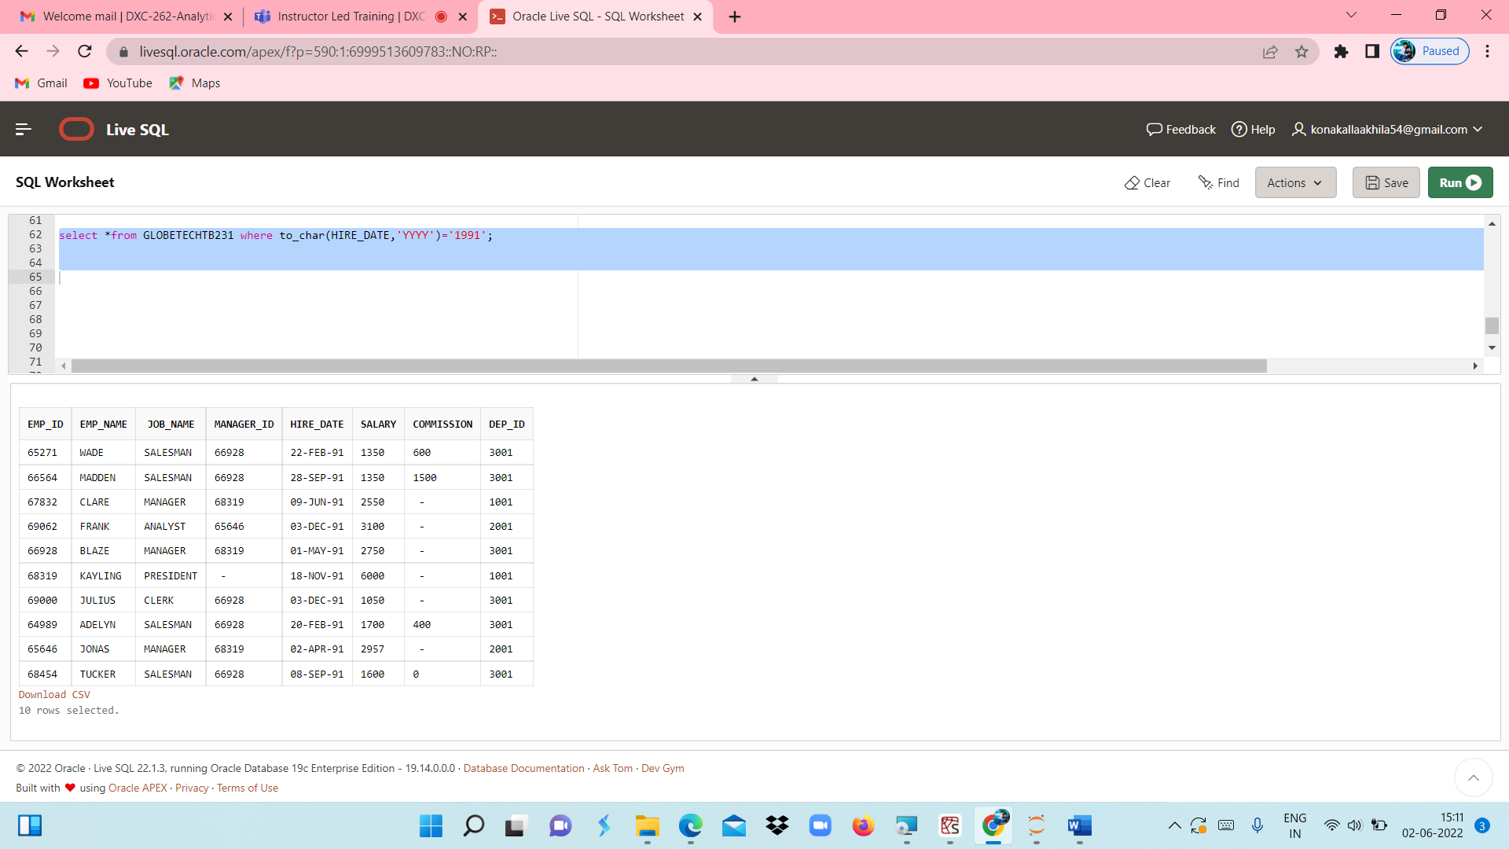

CASE 39 : From the following table, write a SQL query to find those employees who joined in the month of June 1991.Return complete information about the employe

QUERY : **select *from GLOBETECHTB231 where to_char(HIRE_DATE,'MM-YYYY')='06-1991';**

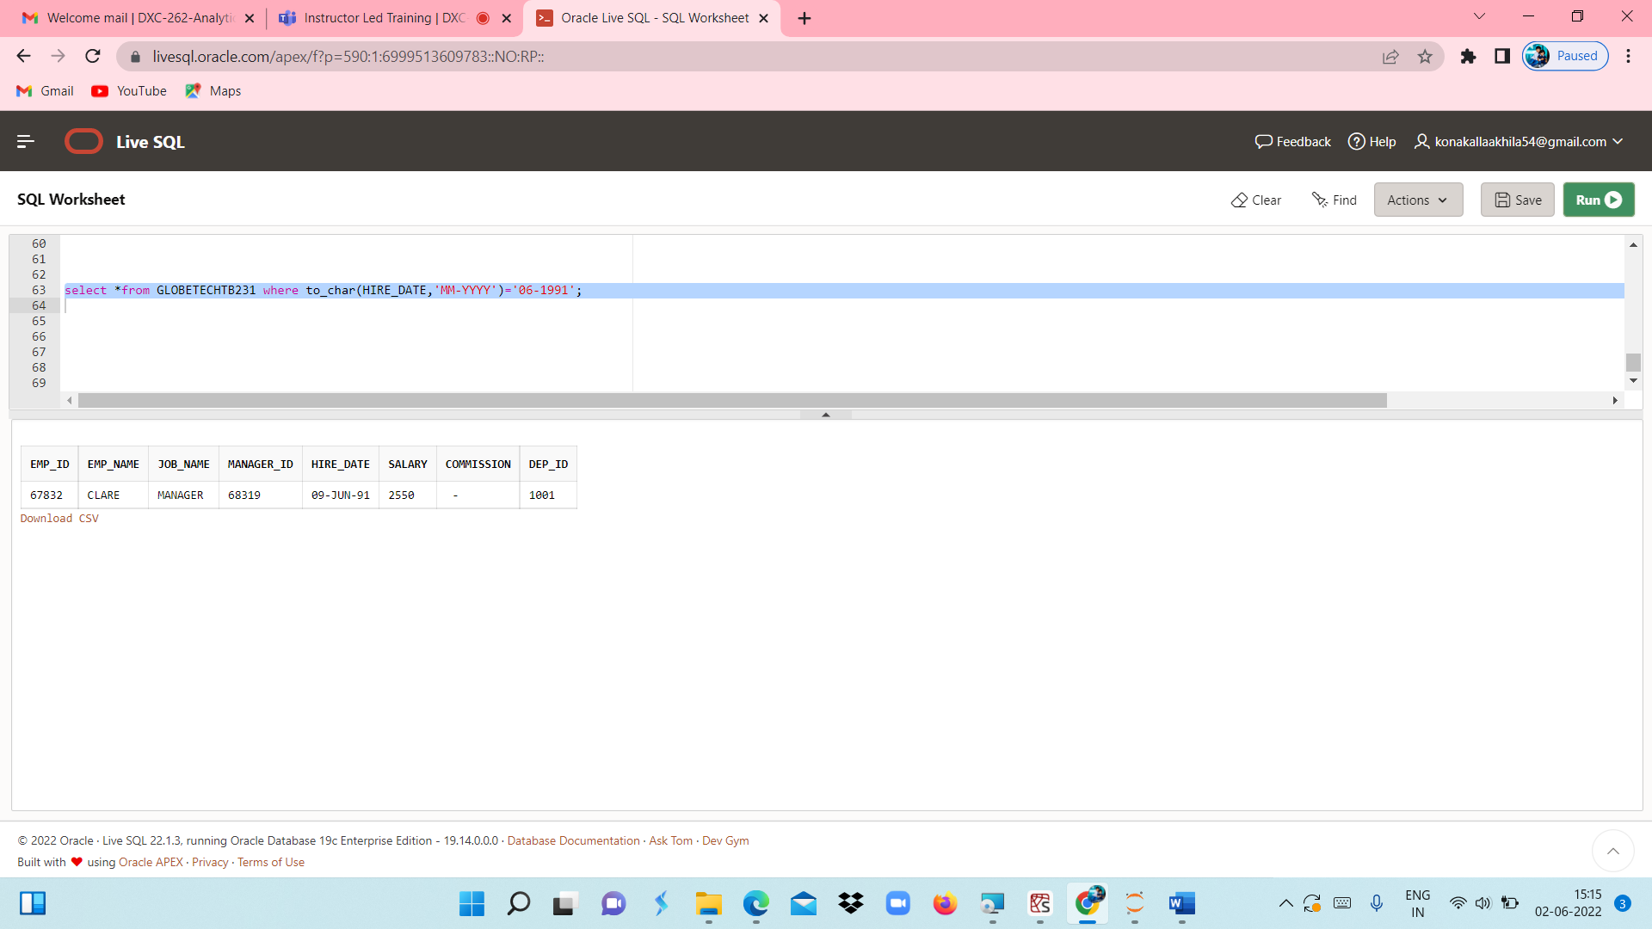

CASE 40 : From the following table, write a SQL query to find all the employees whose annual salary is  
within the range 24000 and 50000 (Begin and end values are included.). Return complete information about the employees.

QUERY : **select *from GLOBETECHTB231 where 12*SALARY between 24000 and 50000;**

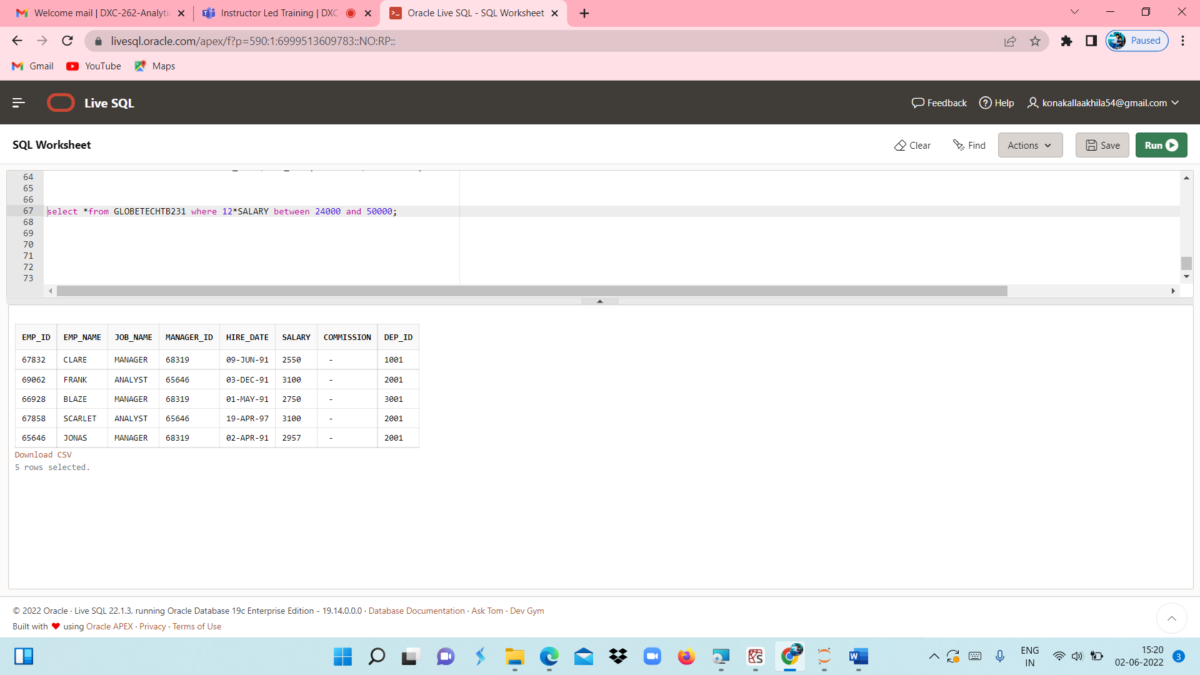

CASE 41 : From the following table, write a SQL query to find all those employees who have joined on 1st May, 20th Feb, and 3rd Dec in the year 1991.Return complete information about the employees.

QUERY: **select *from GLOBETECHTB231 where to_char(HIRE_DATE,'DD-MM')='01-05' or to_char(HIRE_DATE,'DD-MM')='20-02' or to_char(HIRE_DATE,'DD-MM')='03-12';**

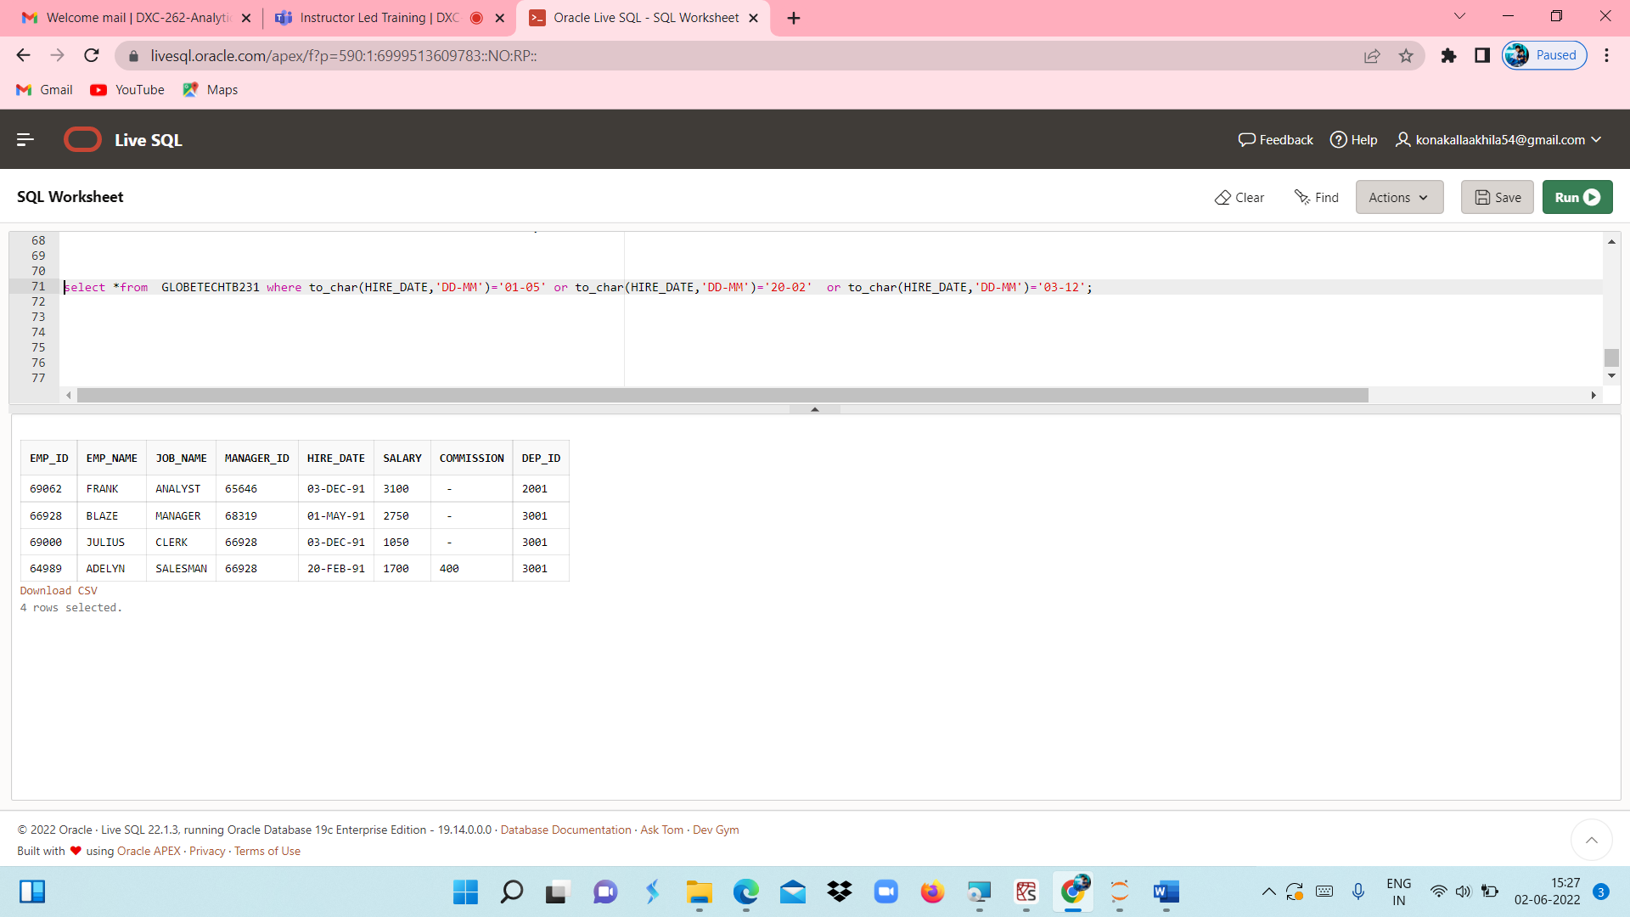

CASE 42 : From the following table, write a SQL query to find those employees working under the managers 63679 or 68319 or 66564 or 69000.Return complete information about the employees

QUERY : **select *from GLOBETECHTB231 where MANAGER_ID='63679' or MANAGER_ID=' 68319' or MANAGER_ID=' 66564' or MANAGER_ID=' 69000';**

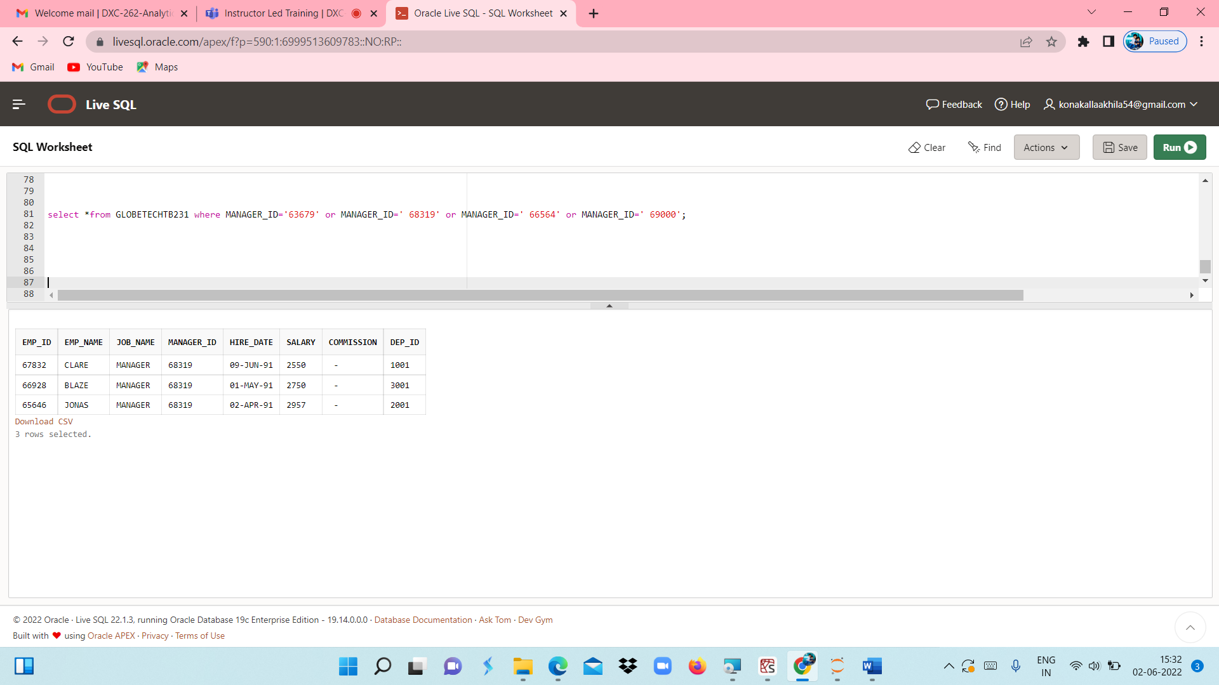

CASE 43 : From the following table, write a SQL query to find those employees who joined after the month JUNE in the year 1991and within this year. Return complete information about the employees

QUERY : **select *from GLOBETECHTB231 where (to_char( HIRE_DATE,'DD-MM-YYYY') between '01-07-1991' and '31-12-1991');**

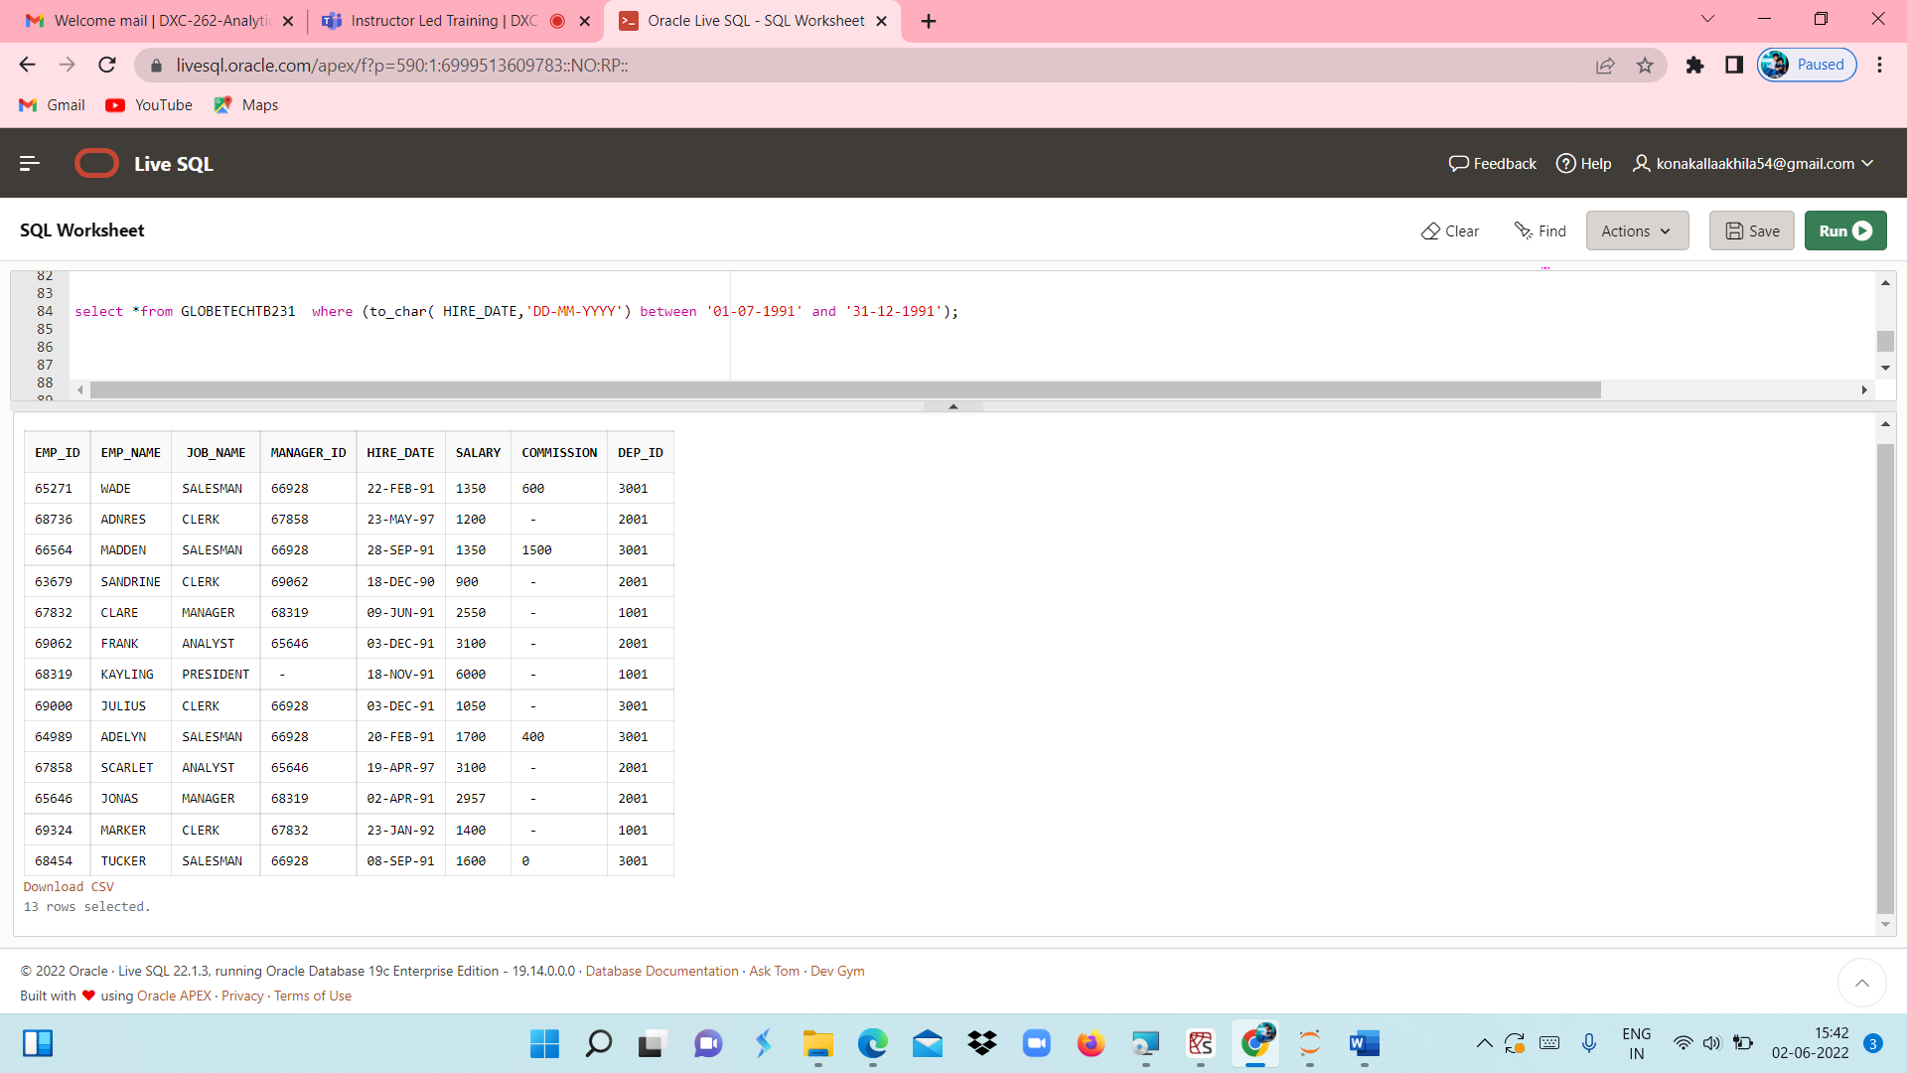

CASE 44 : From the following table, write a SQL query to find those employees who joined in 90's.  
Return complete information about the employees

QUERY : **select *from GLOBETECHTB231 where to_char(HIRE_DATE,'YYYY') between '1990' and '1999';**

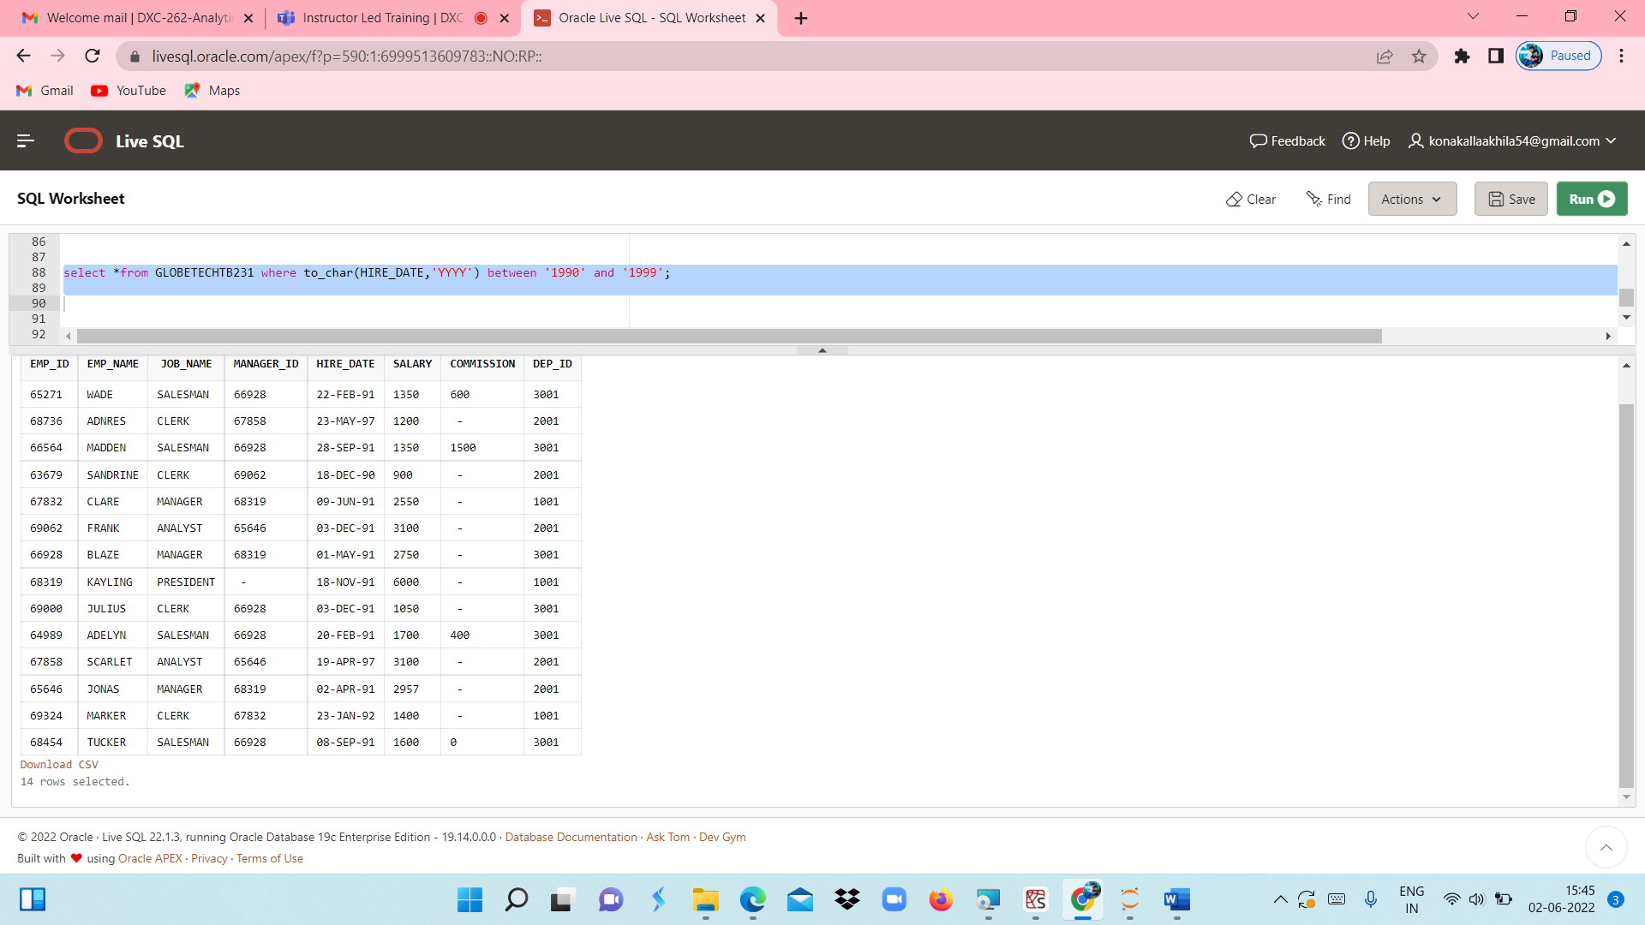

CASE 45 : From the following table, write a SQL query to find those managers who are in the department 1001 or 2001.Return complete information about the employees.

QUERY : **select *from GLOBETECHTB231 where JOB_NAME='MANAGER' and (DEP_ID='1001' or DEP_ID='2001');**

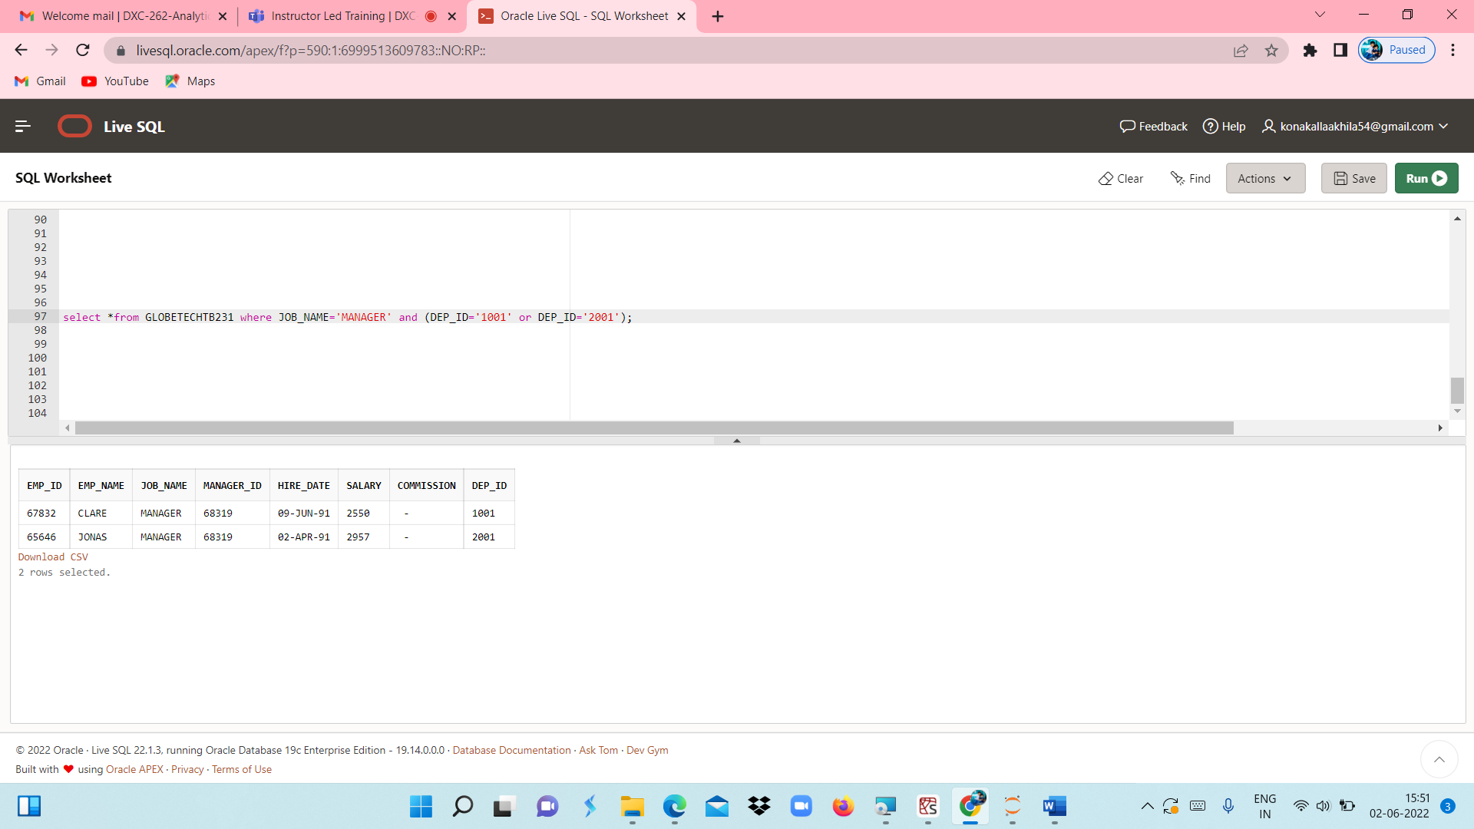

CASE 46 : From the following table, write a SQL query to find those employees who joined in the month FEBRUARY with a salary range between 1001 to 2000 (Begin and end values are included.). Return complete information about the employees

QUERY : **select *from GLOBETECHTB231 where to_char(HIRE_DATE,'MM')='02' and SALARY between 1001 and 2000;**

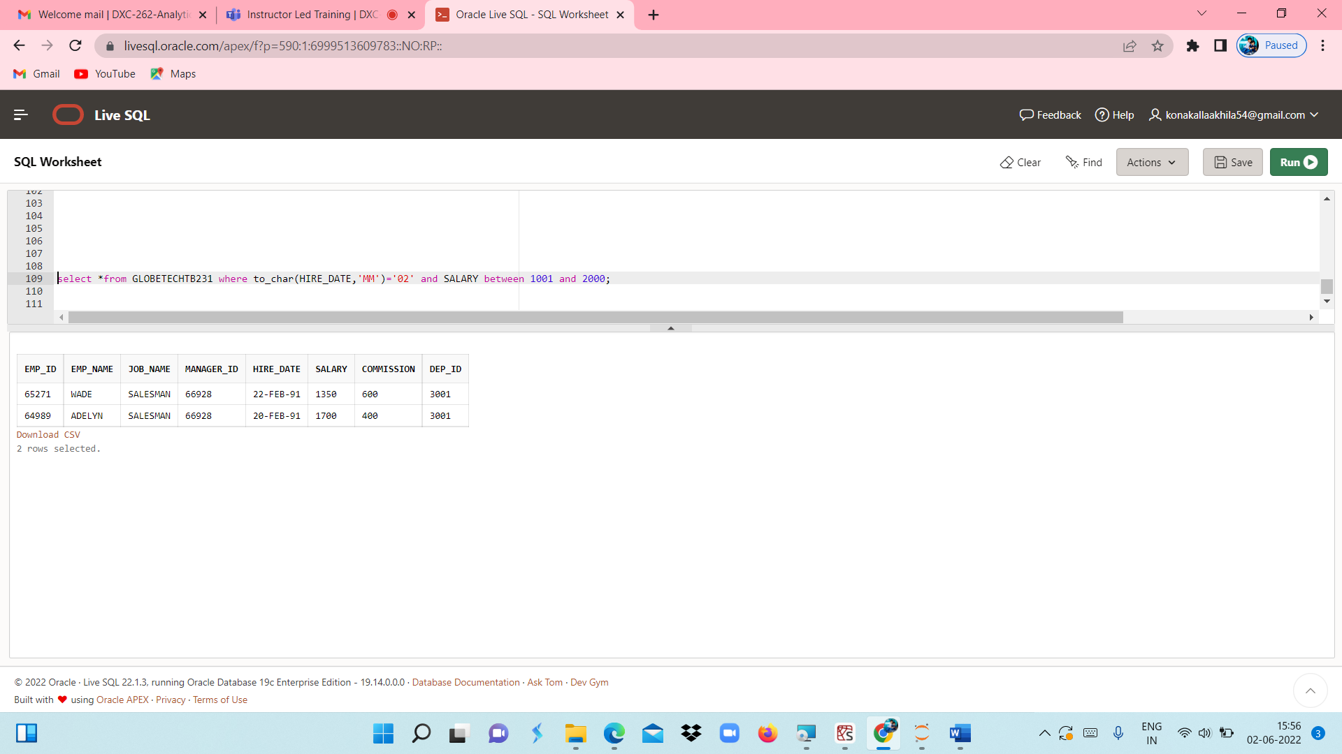

CASE 47 : From the following table, write a SQL query to find those employees who joined before or after the year 1991.Return complete information about the employees.

QUERY **: SELECT * FROM globetechtb231**

**WHERE to_char(hire_date,'YYYY') NOT IN ('1991');**

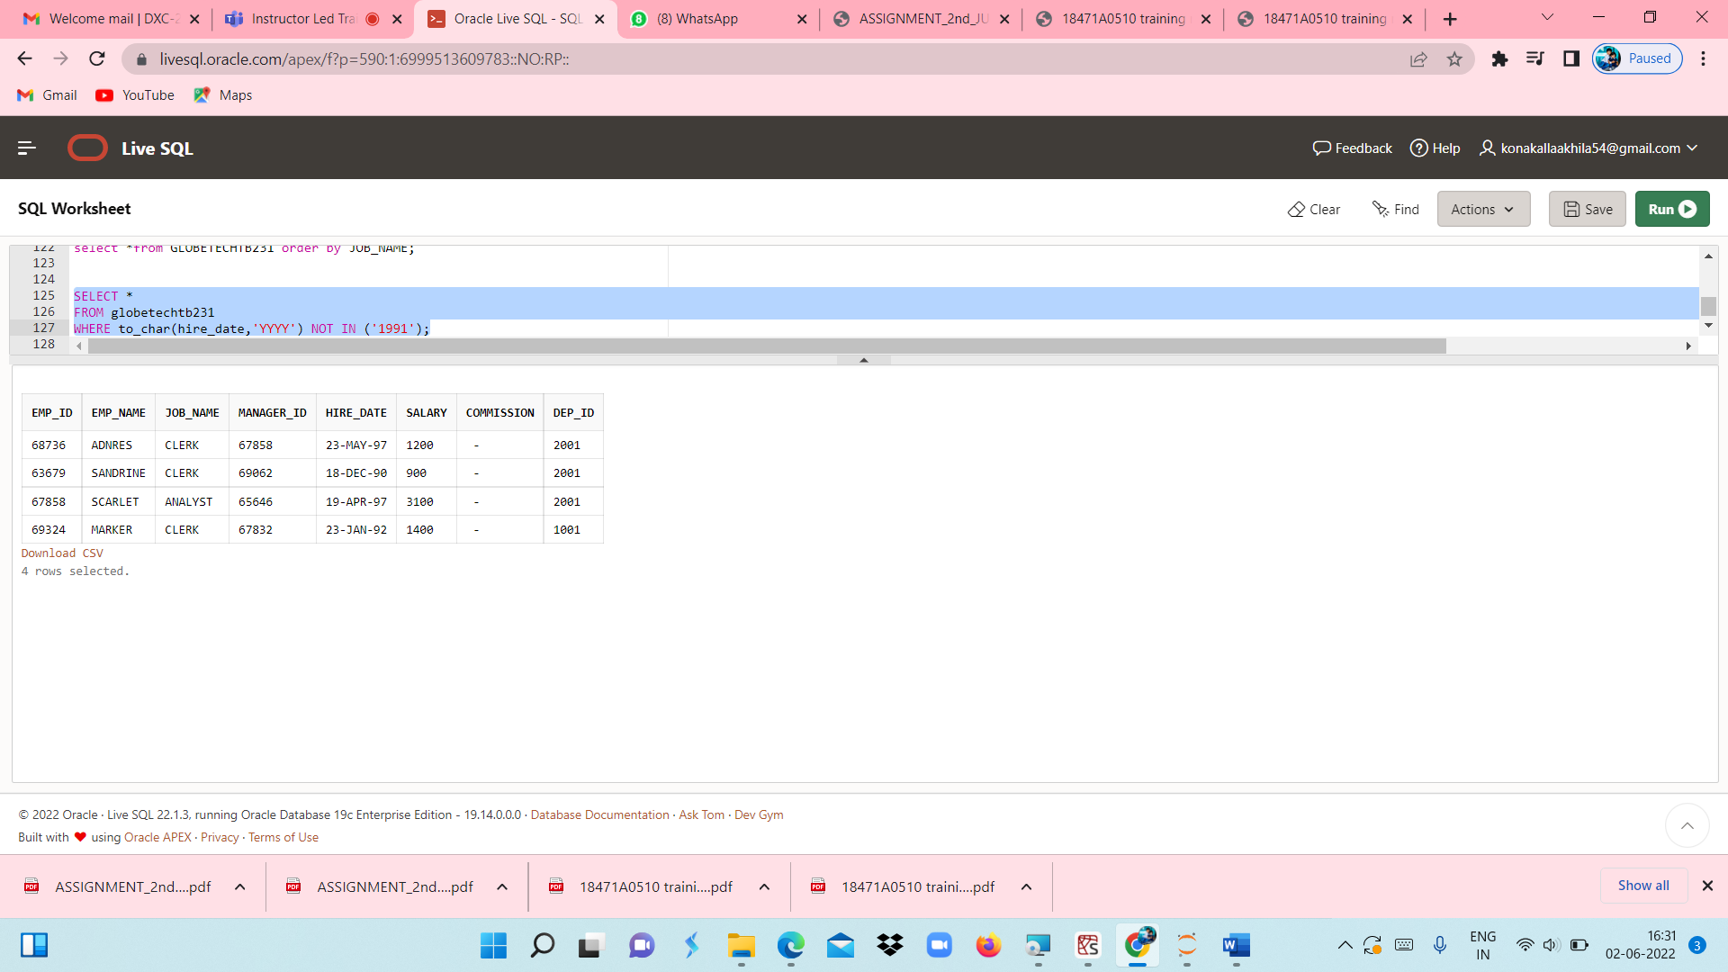

CASE 48 : From the following tables, write a SQL query to find employees along with department name. Return employee ID, employee name, job name, manager ID, hire date, salary, commission, department ID, and department name

QUERY : **select *from GLOBETECHTB231 order by JOB_NAME;**

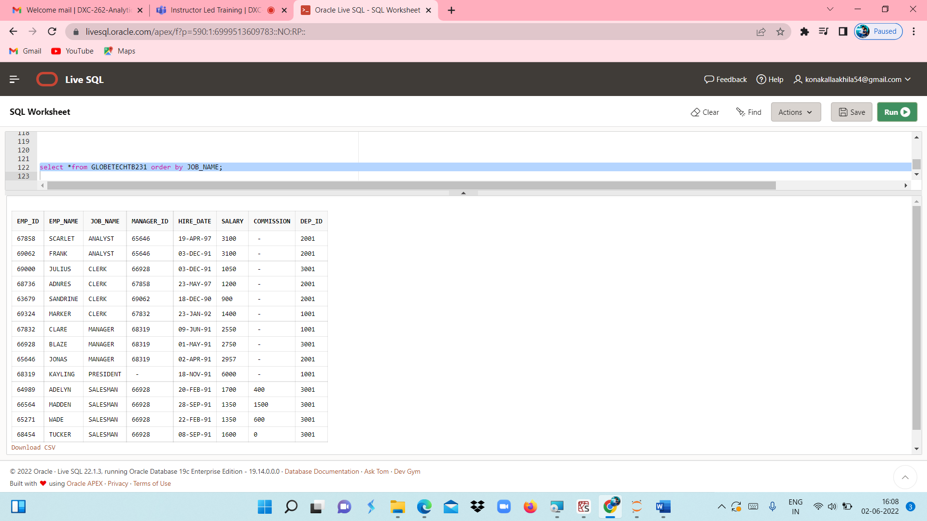

CASE 49 : From the following tables, write a SQL query to find those employees who earn 60000 in a year or not  
working as an ANALYST. Return employee name, job name, (12*salary) as Annual Salary, department ID, and grade

CASE 50 : From the following table, write a SQL query to find those employees whose salary is higher than the salary of their managers.Return employee name, job name, manager ID, salary, manager name, manager's salary.